The 5th International Conference on Sustainable Animal Agriculture for Developing Countries (SAADC2015).

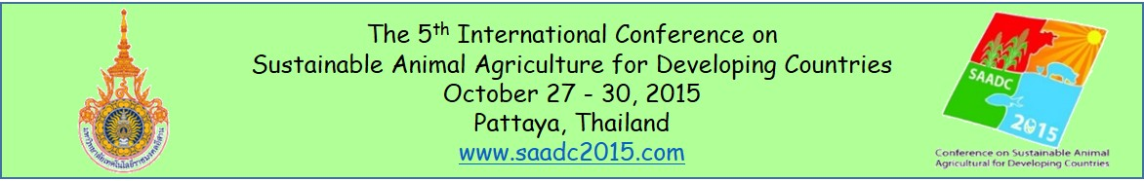
The SAADC 2015 aims to provide a chance for researchers in field of animal science, agriculture and related fields including academicians, researchers, administrators and private sectors both in developing and developed countries to share their own experiences for sustainable animal agriculture production.
IMPORTANT DATES:
Extended for Abstract Submission: March 15, 2015.
Paper Submission (3-page): May 30, 2015.
HOW TO SUBMIT ABSTRACT AND PAPER:
Two ways of submission:
1. Sign up will be available online: www.saadc2015.com
2. You may send abstract directly to saadc2015@sci.rmuti.ac.th
For more information: www.saadc2015.com

The SAADC2015 conference offers keynote speeches, oral and poster presentation sessions, and exhibition.
The conference invites the submission of scientific papers relating to the following areas:
Animal Nutrition Basic Veterinary Science
Animal Genetics/Breeding Medicine and Surgery
Animal Physiology Veterinary Public Health
Animal Reproduction Livestock Management
Animal Biotechnology Livestock Farming System
Feed Technology Aquaculture
Meat Science

